CREATE LOAD BALANCER USING TERRAFORM (us-east-1)

1. Login aws account

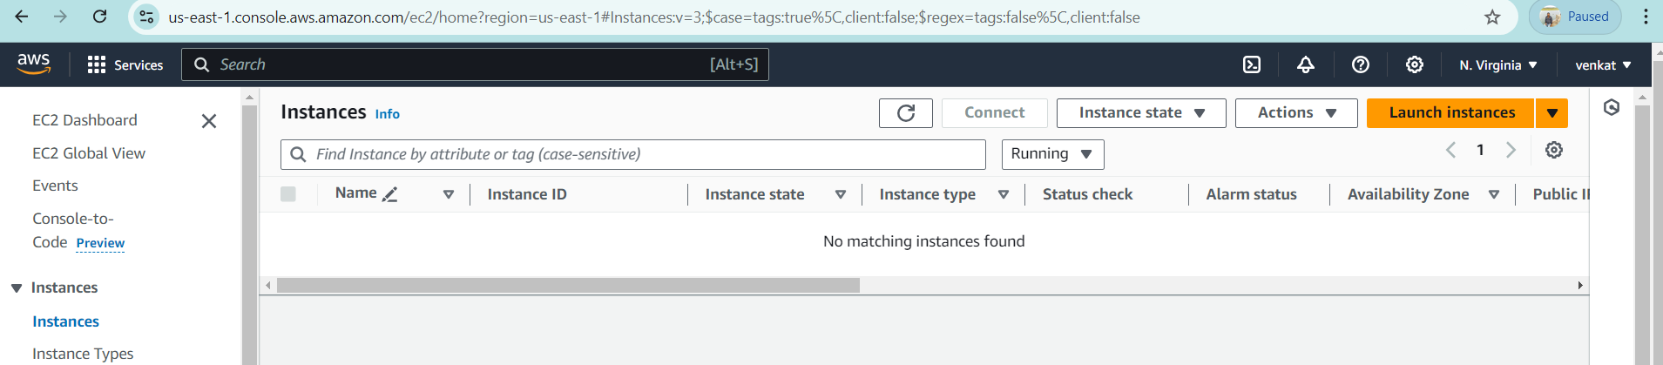

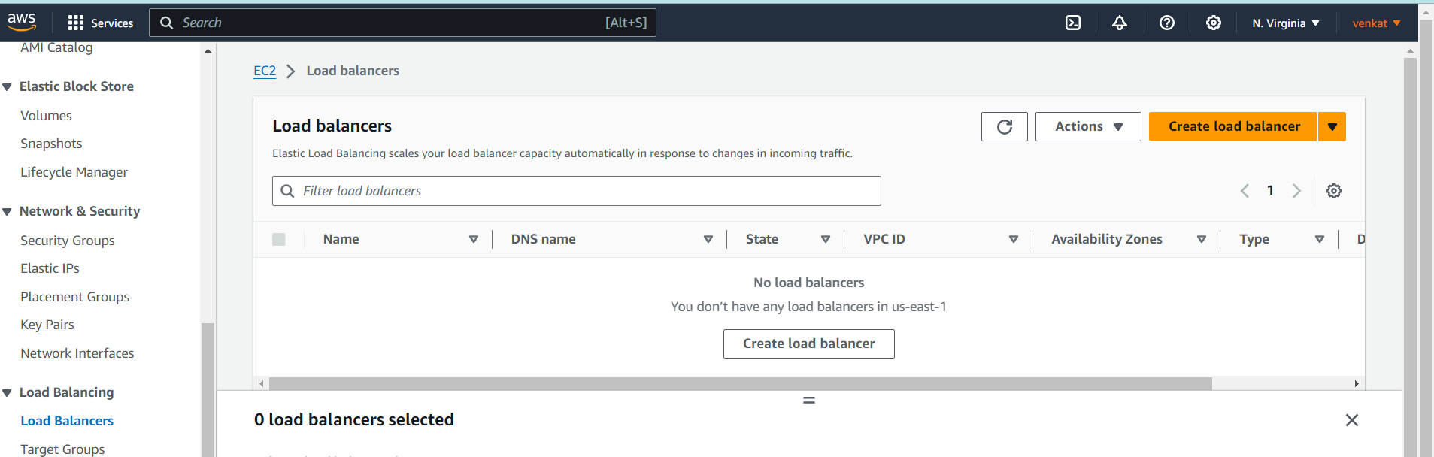

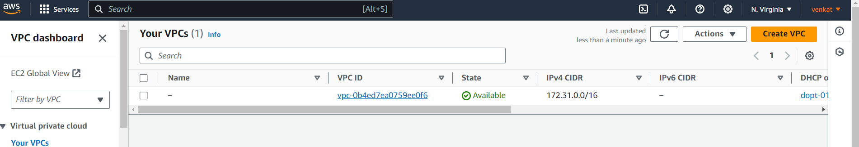

1. Now open visual studio code
2. Select folder
3. Crete file provider.tf

provider "aws" {

region = "us-east-1"

}

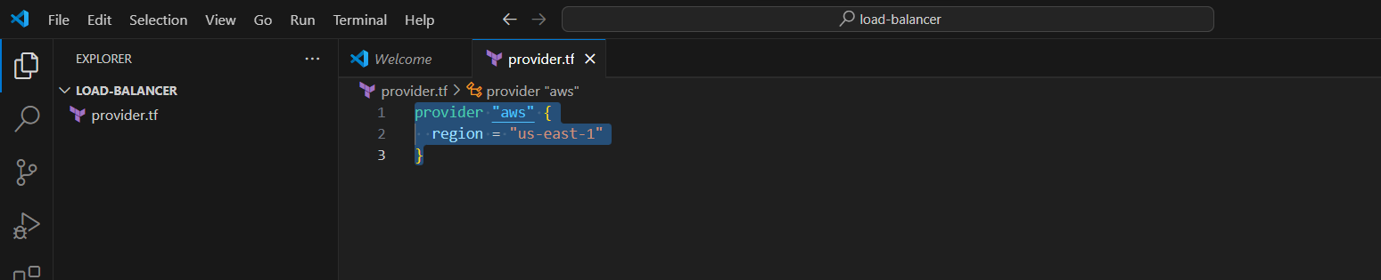

1. Now create vpc.tf

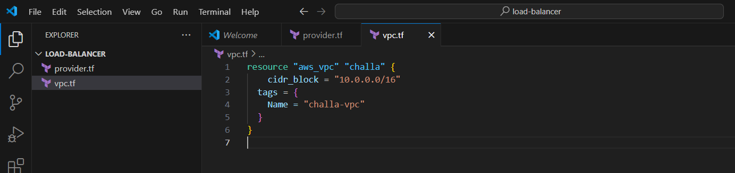

resource "aws_vpc" "challa" {

cidr_block = "10.0.0.0/16"

tags = {

Name = "challa-vpc"

}

}

1. Now create subnet.tf

resource "aws_subnet" "challa-public-subnet1" {

vpc_id = aws_vpc.challa.id

cidr_block = "10.0.0.0/24"

map_public_ip_on_launch = "true"

availability_zone = "us-east-1a"

tags = {

Name = "challa-public-subnet1"

}

}

#public-subnet2 creation

resource "aws_subnet" "challa-public-subnet2" {

vpc_id = aws_vpc.challa.id

cidr_block = "10.0.1.0/24"

map_public_ip_on_launch = "true"

availability_zone = "us-east-1b"

tags = {

Name = "challa-public-subnet2"

}

}

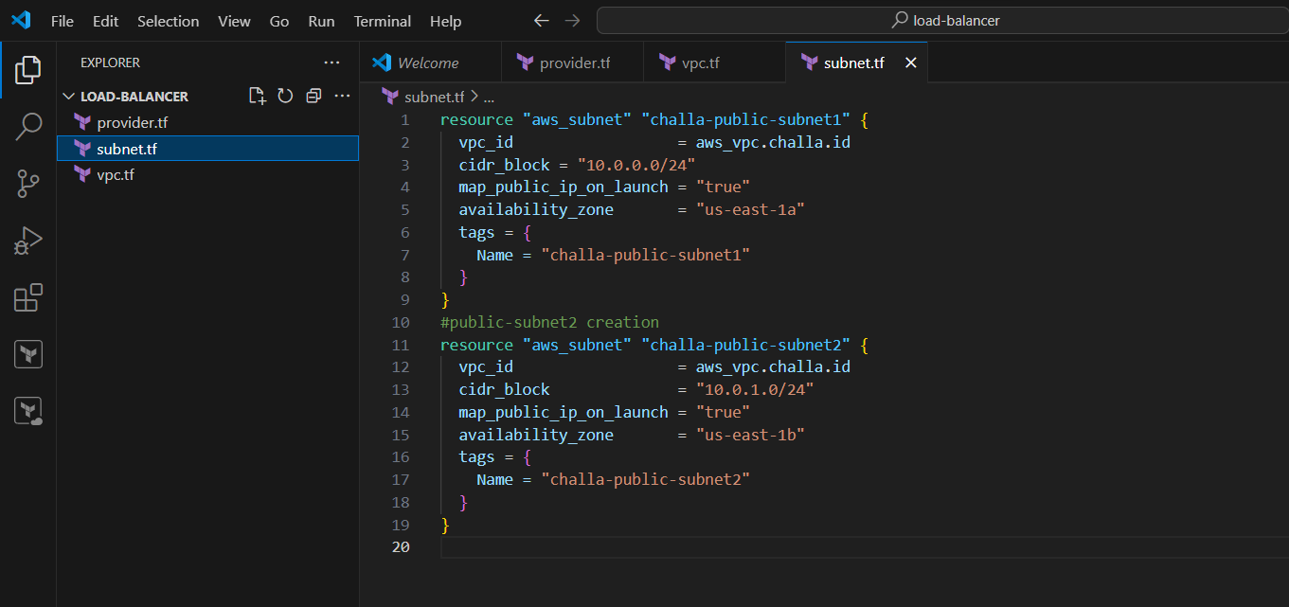

1. Now create igw.tf

resource "aws_internet_gateway" "challa-gateway" {

vpc_id = aws_vpc.challa.id

}

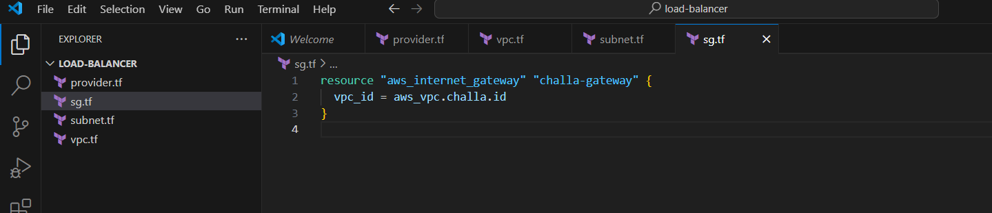

1. Now create route table add route and subnet association
2. route.tf

resource "aws_route_table" "challa-route" {

vpc_id = aws_vpc.challa.id

route {

cidr_block = "0.0.0.0/0"

gateway_id = aws_internet_gateway.challa-gateway.id

}

tags = {

Name = "route to internet"

}

}

#route 1

resource "aws_route_table_association" "challa-route1" {

subnet_id = aws_subnet.challa-public-subnet1.id

route_table_id = aws_route_table.challa-route.id

}

#route 2

resource "aws_route_table_association" "challa-route2" {

subnet_id = aws_subnet.challa-public-subnet2.id

route_table_id = aws_route_table.challa-route.id

}

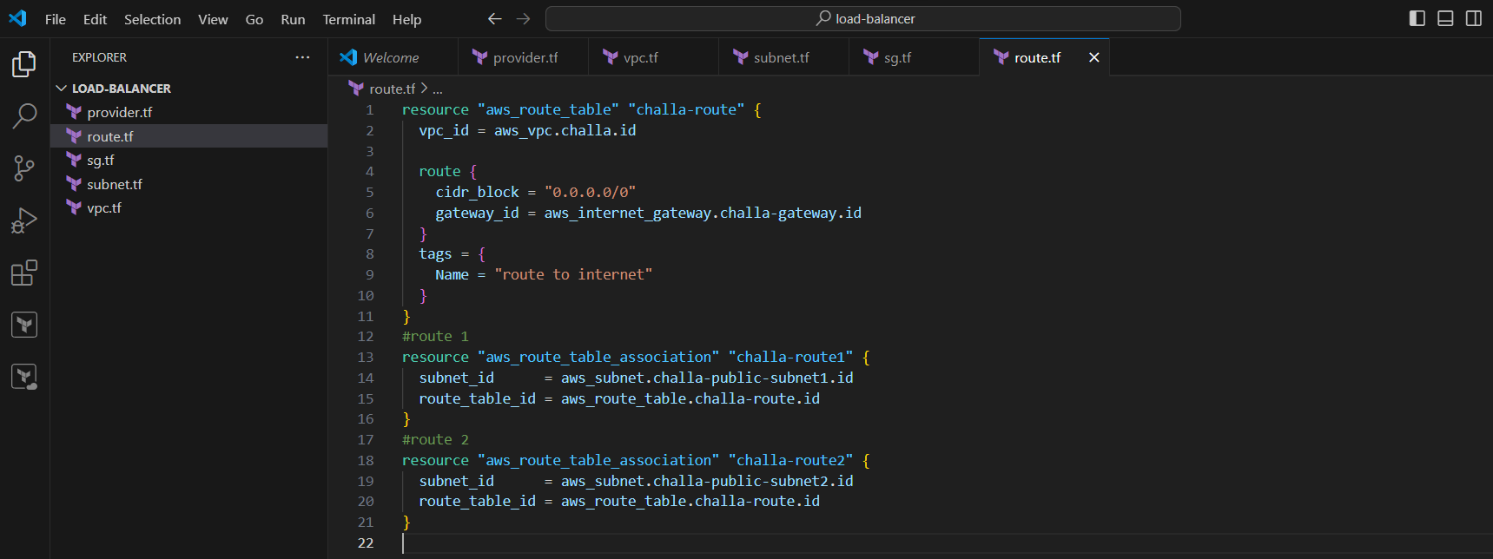

1. Now create security group sg.tf

resource "aws_security_group" "challa-sg" {

vpc_id = aws_vpc.challa.id

ingress {

from_port = 80

to_port = 80

protocol = "tcp"

cidr_blocks = ["0.0.0.0/0"]

}

ingress {

from_port = 443

to_port = 443

protocol = "tcp"

cidr_blocks = ["0.0.0.0/0"]

}

ingress {

from_port = 22

to_port = 22

protocol = "tcp"

cidr_blocks = ["0.0.0.0/0"]

}

egress {

from_port = 0

to_port = 0

protocol = "-1"

cidr_blocks = ["0.0.0.0/0"]

}

tags = {

Name = "challa-sg"

}

}

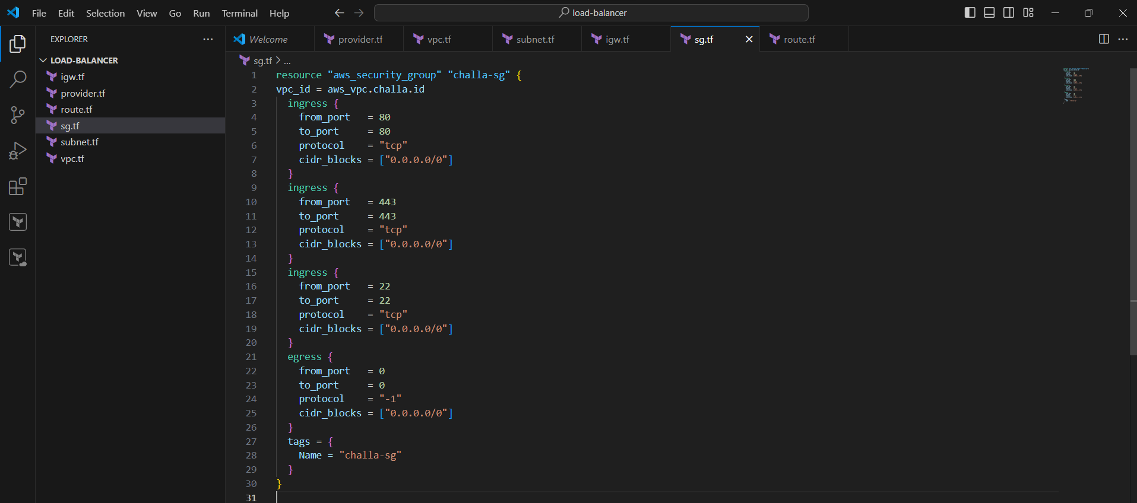

1. Now create 2 ec2 instance ec2.tf

resource "aws_instance" "challa" {

ami = "ami-0ae8f15ae66fe8cda"

instance_type = "t2.micro"

key_name = "challa"

vpc_security_group_ids = [aws_security_group.challa-sg.id]

subnet_id = aws_subnet.challa-public-subnet1.id

associate_public_ip_address = true

user_data = file("${path.module}/appache1.sh")

tags = {

Name = "challa"

}

}

resource "aws_instance" "rao" {

ami = "ami-0ae8f15ae66fe8cda"

instance_type = "t2.micro"

key_name = "rao"

vpc_security_group_ids = [aws_security_group.challa-sg.id]

subnet_id = aws_subnet.challa-public-subnet2.id

associate_public_ip_address = true

user_data = file("${path.module}/appache2.sh")

tags = {

Name = "rao"

}

}

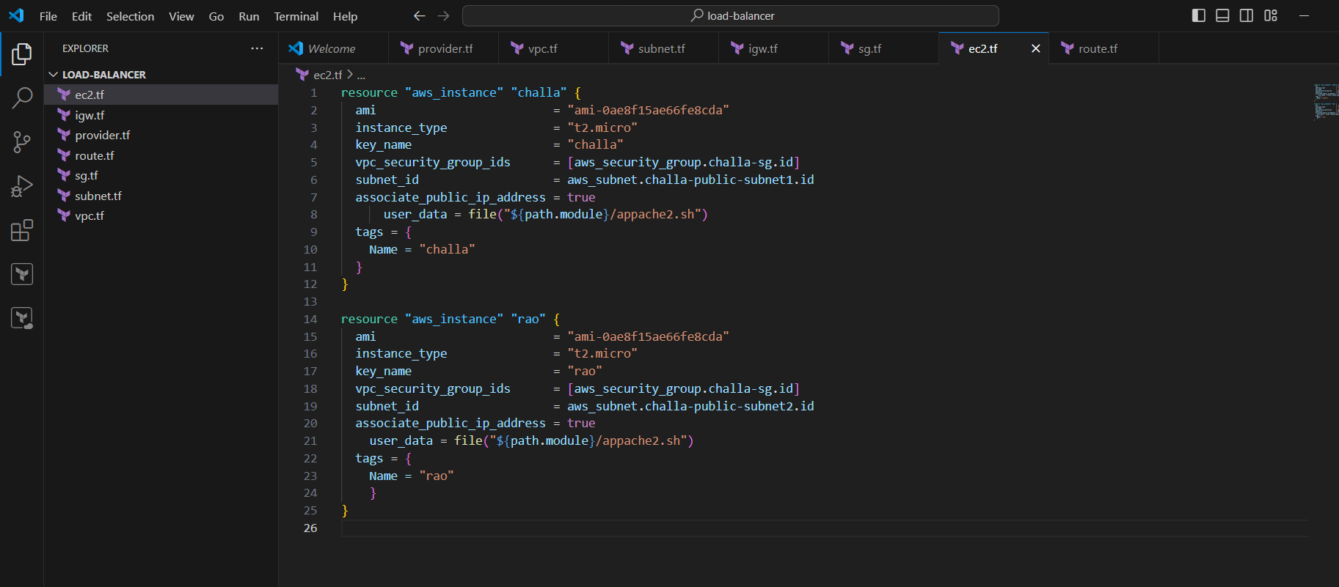

1. Now create appache1.sh to install nginx for challa instance

#appache1.sh

#!/bin/bash

sudo apt update -y &&

sudo apt install -y nginx

echo "hi this is challa" > /var/www/html/index.html

sudo systemctl restart nginx.service

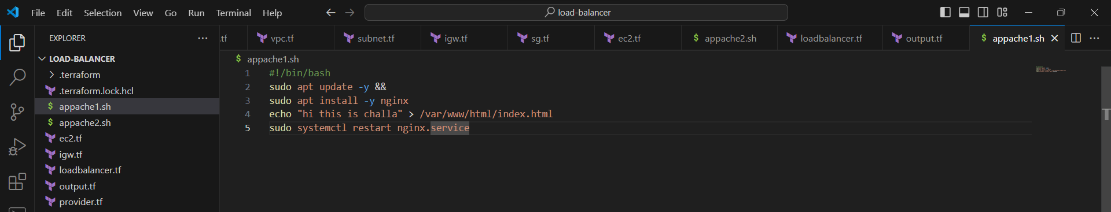

1. Now create appache2.sh to install nginx for rao instance

#appache2.sh

#!/bin/bash

sudo apt update -y &&

sudo apt install -y nginx

echo "hi this is rao" > /var/www/html/index.html

sudo systemctl restart nginx.service

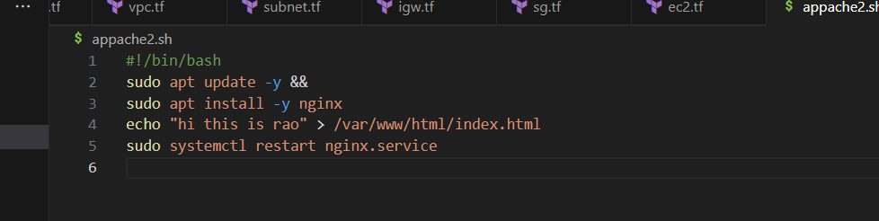

1. Now create load balancer and target group

resource "aws_lb" "challa-alb" {

name = "challa-LB"

internal = false

load_balancer_type = "application"

security_groups = [aws_security_group.challa-sg.id]

subnets = [aws_subnet.challa-public-subnet1.id, aws_subnet.challa-public-subnet2.id]

}

resource "aws_lb_target_group" "challa-tg" {

name = "challa-TG"

port = 80

protocol = "HTTP"

vpc_id = aws_vpc.challa.id

health_check {

path = "/health"

port = 80

protocol = "HTTP"

}

}

resource "aws_lb_target_group_attachment" "challas" {

target_group_arn = aws_lb_target_group.challa-tg.arn

target_id = aws_instance.challa.id

port = 80

depends_on = [

aws_lb_target_group.challa-tg,

aws_instance.challa,

]

}

resource "aws_lb_target_group_attachment" "raos" {

target_group_arn = aws_lb_target_group.challa-tg.arn

target_id = aws_instance.rao.id

port = 80

depends_on = [

aws_lb_target_group.challa-tg,

aws_instance.rao,

]

}

resource "aws_lb_listener" "listener_elb" {

load_balancer_arn = aws_lb.challa-alb.arn

port = 80

protocol = "HTTP"

default_action {

type = "forward"

target_group_arn = aws_lb_target_group.challa-tg.arn

}

}

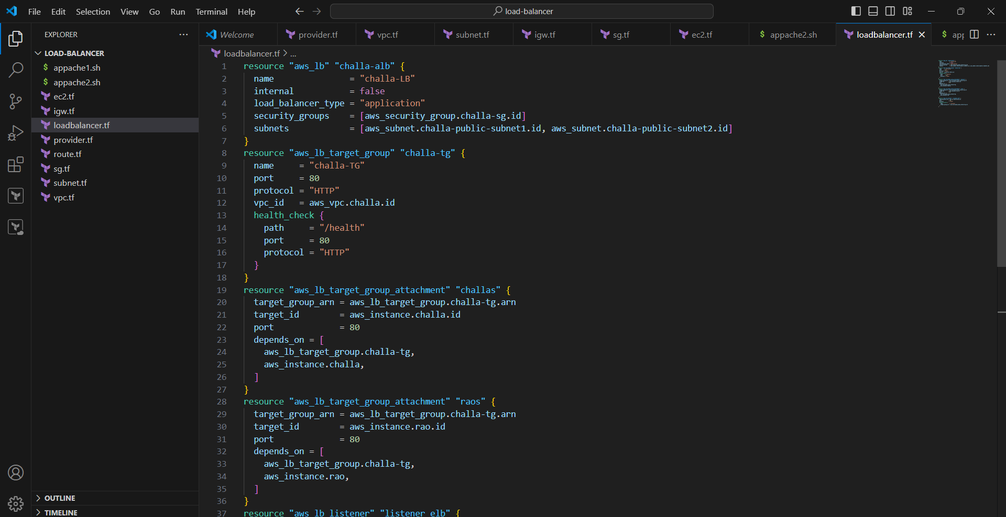

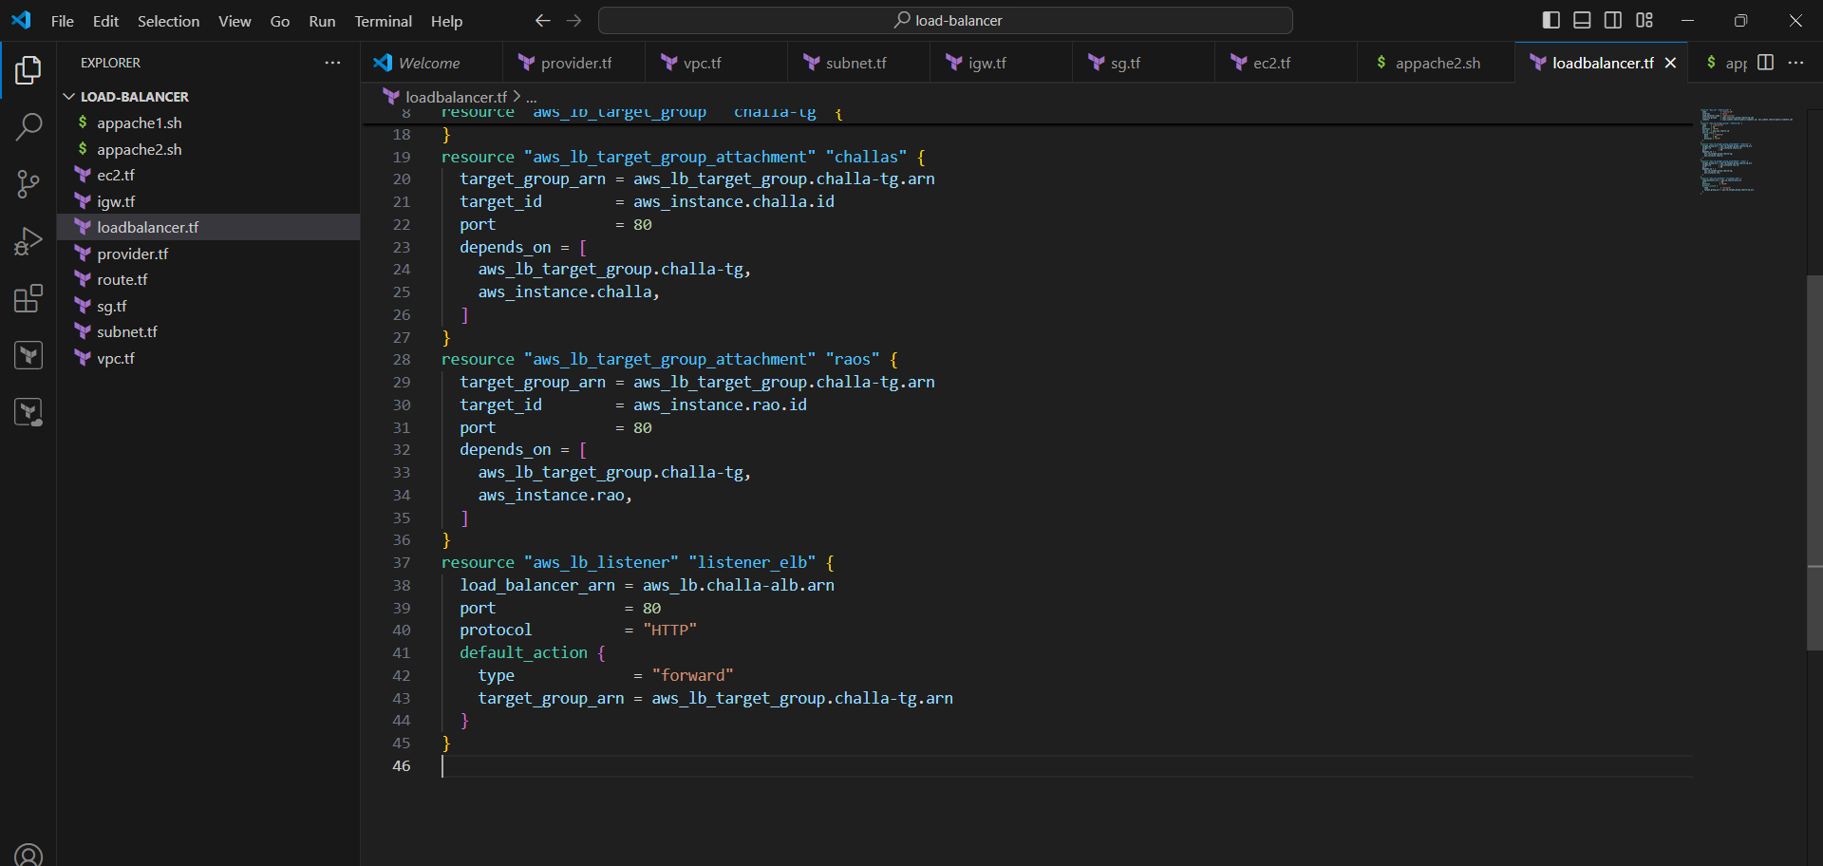

1. Now create output.tf

#output.tf

#DNS of LoadBalancer

output "lb_dns_name" {

description = "DNS of Load balancer"

value = aws_lb.challa-alb.dns_name

}

output "instance_public_ip" {

description = "Public IP address of the EC2 instance"

value = aws_instance.rao.public_ip

}

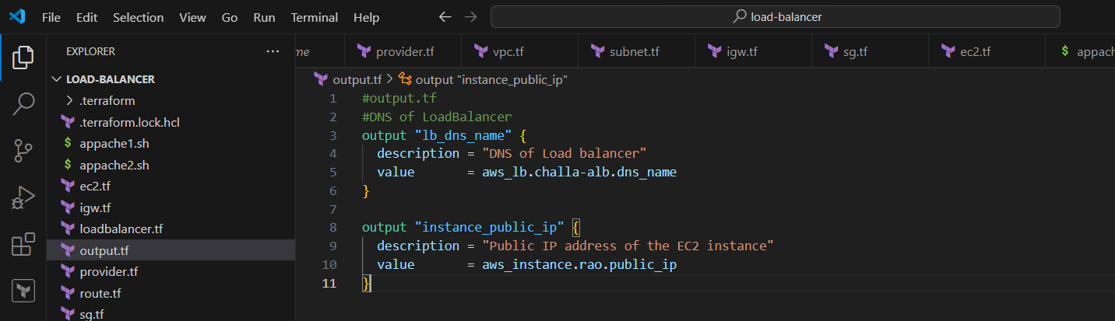

1. Now save all
2. Now click on terminal select new terminal

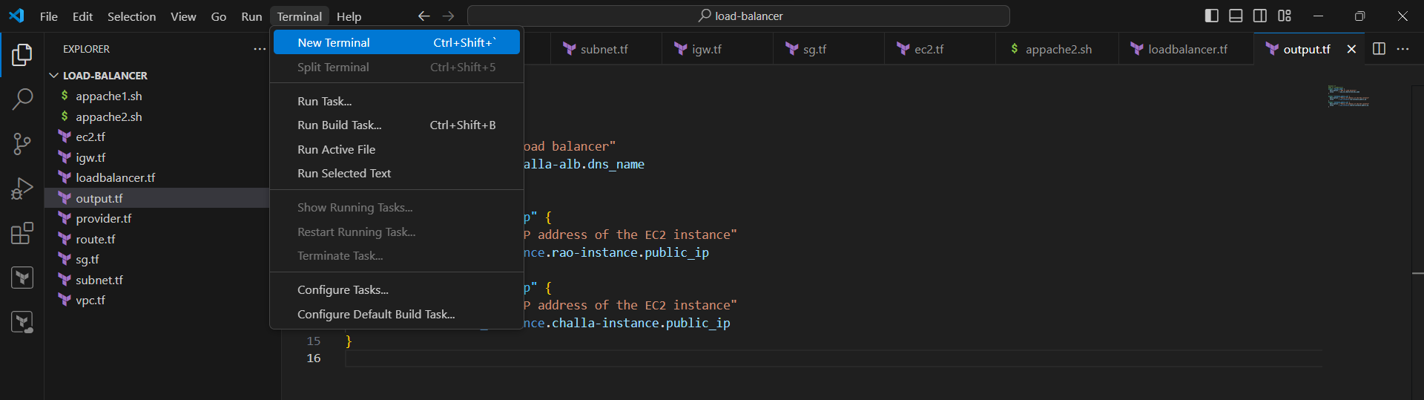

1. Now click on terminal and use #terraform init

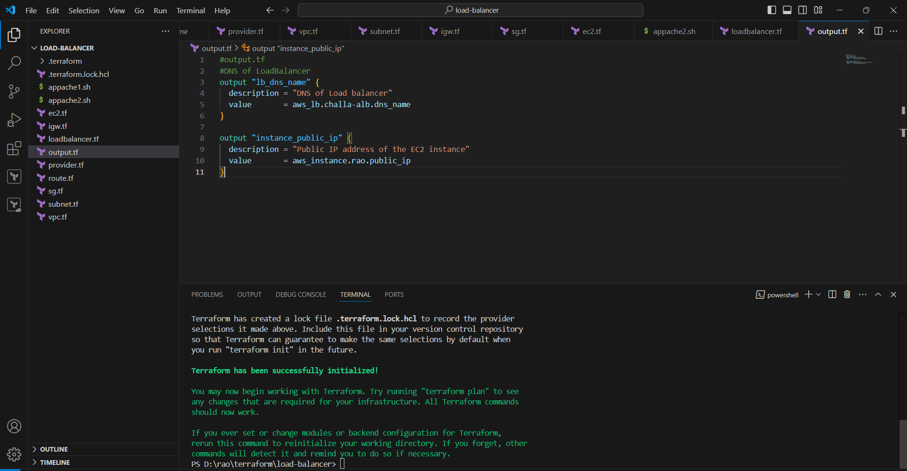

1. #terraform validate

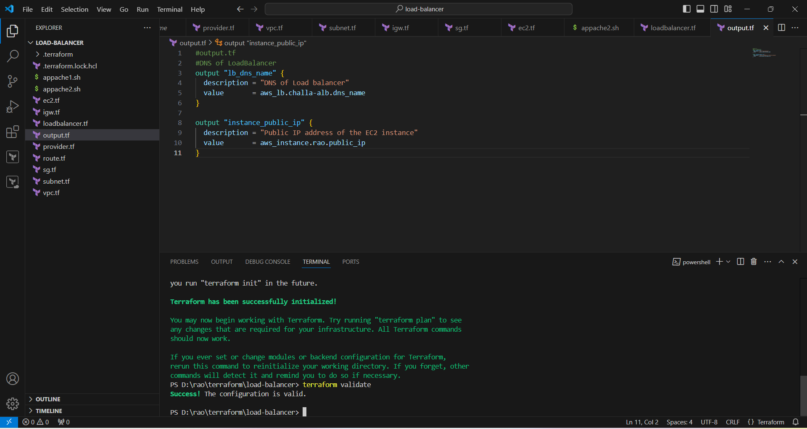

1. Now terraform plan #terraform plan

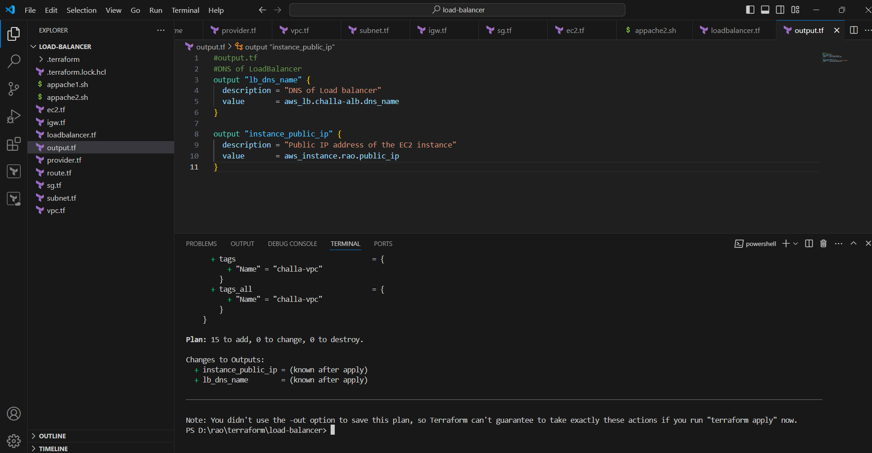

1. Now terraform apply #terraform apply --auto-aprove

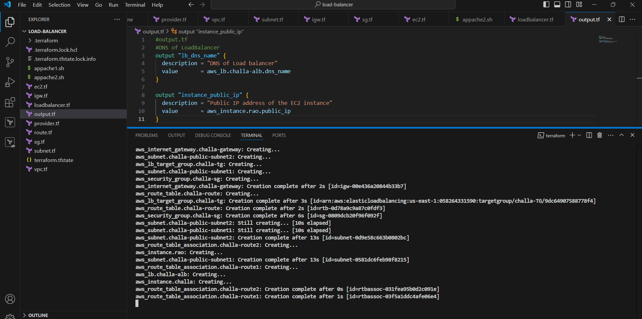

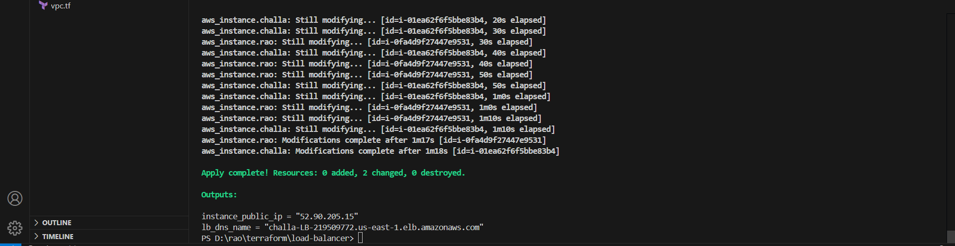

1. Copy dns and paste in google
2. 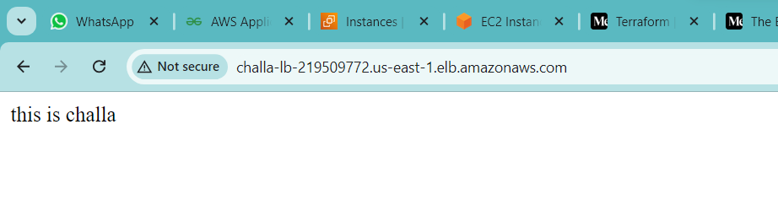
3. Refresh
4. 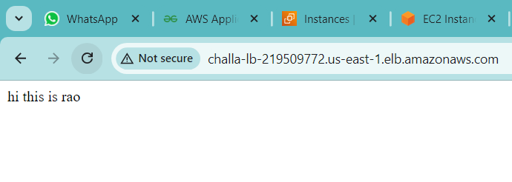
5. Once go and check instances and load balancers
6. 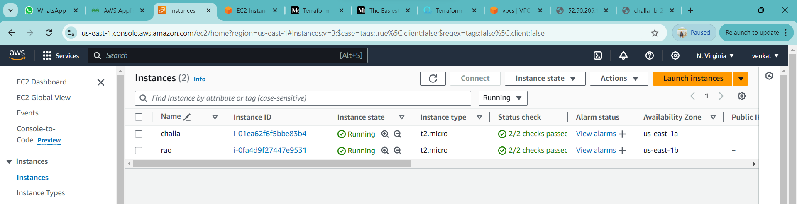
7. 
8. 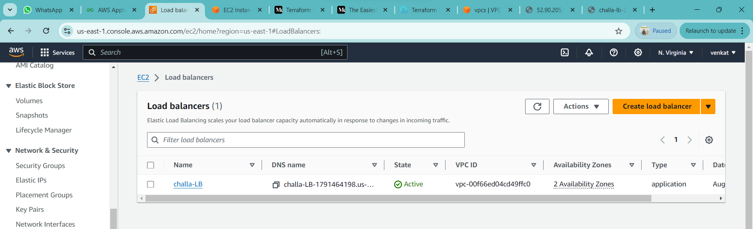
9. 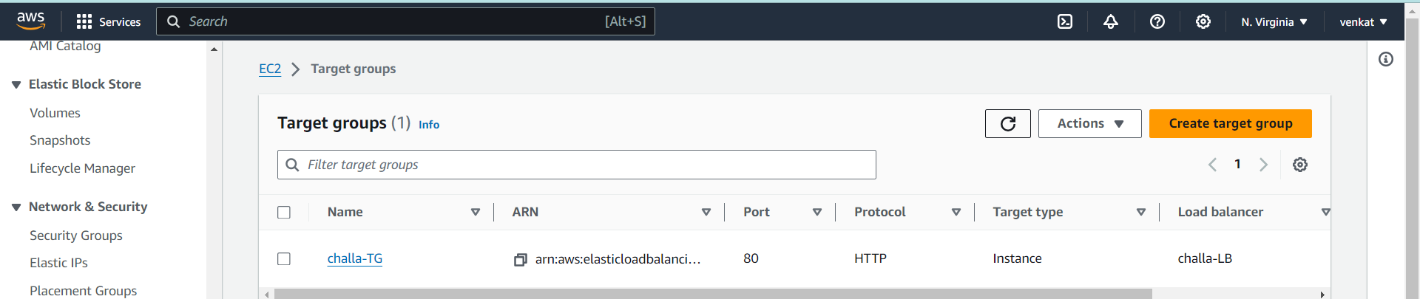
10. 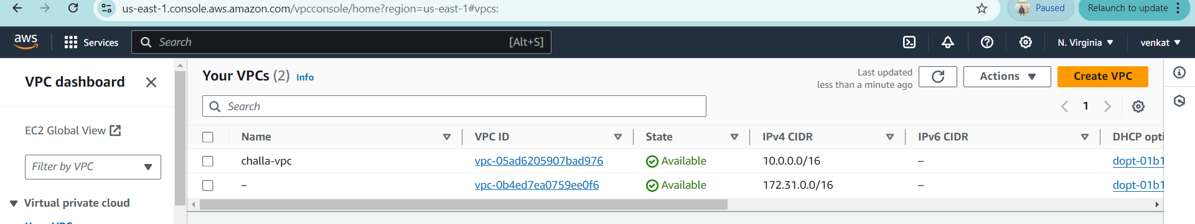
11. 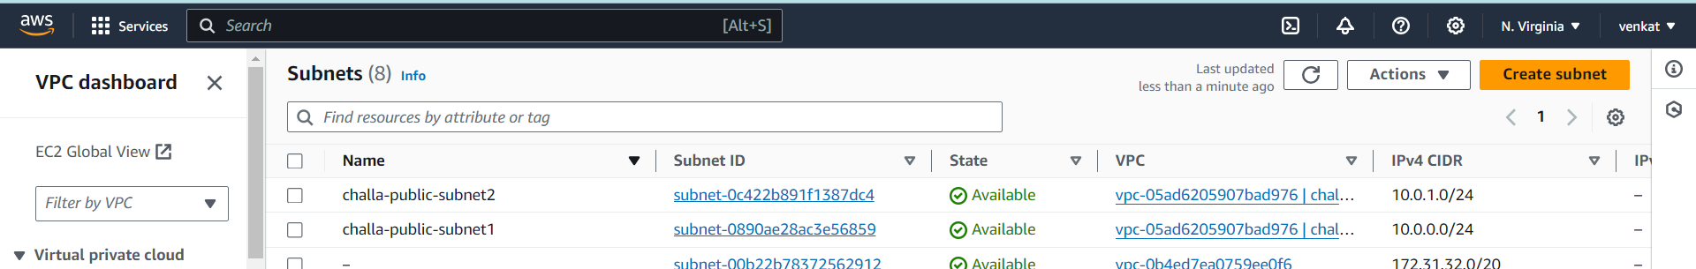

========================================================================

If you want destroy use #terraform destroy



